



**Kevin Scardino**:Project Manager, GIS Analyst, Point of Contact

**Nathan Andrews**:Assistant Project Manager, GIS Analyst, Web Master

**Barkley Jenkins**:GIS Technician, Data Specialist

**Mukarram Kamran**:GIS Analyst, Technical Writer

**The City of New Braunfels**

**Parks and Recreations**

**Asset Management Project**

**Prepared by: The G.A.M.E.S.**

**Table of Contents**

1. Introduction

1.1. Summary………………………………………………………………………… 1

1.2. Purpose………………………………………………………………………….. 1-2

1.3. Scope……………………………………………………………………………. 2-3

2. Proposal

2.1. Data……………………………………………………………………………… 3

2.2. Methodology …………………………………………………………………….. 4-6

2.3. Implications……………………………………………………………………… 6-7

3. Budget………………………………………………………..…………….………………. 8

4. Timetable………………………………………………………………….…..…………… 9

5. Final Deliverables…………………………………………………….….….……………... 10

6. Conclusions……………………………………………………….…..……………… 11-12

7. Participation………………………………………….……………….…………………... 13

8. References…………………………………………….……………….………………….. 14

1. Introduction

1.1 Summary

GIS has become an increasingly important tool for Municipal Governments to have in the management of their cities day to day routines. One such prime example can be found in Las Vegas where the city’s Department of Operations and Maintenance developed ParkPAD (Park Asset Data Collection and Data Conversion Program) an application that can be used to “to collect and manage park assets” (Joel Hillhouse, ESRI.com) in the field using GIS and ArcPad software and it “has produced some immediate cost benefits to the city” (Joel Hillhouse, ESRI.com). Being another city looking to improve on its asset management, New Braunfels is setting its goals in a similar direction and is looking to create an asset GIS schema for their Parks and Recreations Department with the ultimate goal of it being implemented into their existing Accela asset management system. Integrating GIS with a management system like Accela can be extremely useful to any city. Our team The G.A.M.E.S. (Geospatial Asset Management Engineering Solutions) at Texas State University believe that such an endeavor will result in the Parks and Recreations Department being able to better manage their assets and infrastructure, predict maintenance costs months in advance, track/place work orders, track employee’s time, inventorying and many other cost and time saving applications/solutions for their parks.

1.2 Purpose

Our purpose is to collaborate with the City of New Braunfels (CoNB) GIS Department in developing an asset GIS schema for the City’s Parks and Recreations Department that will be able to integrate in with the City’s current Accela’s asset management system and that will be able to “serve as the structure for inventorying this asset information”(City of New Braunfels).

In order to achieve this goal our team will:

* Set up meetings with employees of the Parks and Recreational Department, Kelly Eby and Kelsey Heiden, to get a list of what all is to be considered an “asset”.
* Design a GIS schema or geodatabase around the assets of the parks
* Conduct field work with GPS units as well as moderate digitizing in order to collect any necessary data.
* Finally, the team will help the CoNB GIS Analyst/Accela Manager William Flynn synch the GIS schema/database with Accela linking all of the Park and Recreation assets into the Accela management system.

1.3 Scope

The geographic extent of this project is relative to the amount of land or assets that the City of New Braunfels wants to claim as the Park and Recreational Departments, and therefore not set in stone. However, our team will endeavor to complete a thorough geodatabase of the parks assets in the time allotted for the project and collect any extra field data needed, as well as test and ensure that the geodatabase works correctly. The data gathering will be focused on the assets from parks that are recommended by William Flynn or the Parks and Rec’s Dept. as being top priority. This is because we understand the importance of such a project and how it will ensure “that the right assets are located in the right places and that they are planned, programmed, and maintained to meet identified community needs.”(Dan Saltzman. Portlandonline.com)

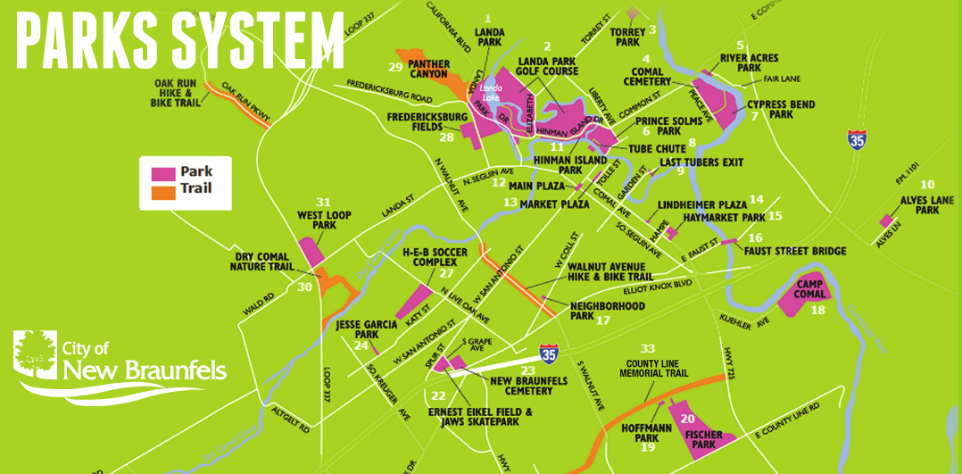

(Image1: http://www.newbraunfelsfunthingsinlife.com/)

2. Proposal

2.1 Data

The data we will need for this project includes numerous amounts of shape files containing the parks and recreations boundaries, buildings, and assets that the client desires in their database. Most of the data has been provided through an FTP server that our client controls and gave us access to. Any other data necessary to the complete the client’s requirements will be collected in the field with the Trimble Geo XT GPS unit. If needed, we will use pathfinder office software in order to create our data dictionary, do differential correction, and transfer data from GPS unit to the GIS database. The other software we will be using is ArcGIS Desktop 10.0, ArcGIS Server 10.0 and the City of New Braunfels’ asset management system Accela.

2.2 Methodology

The successful design and implementation of an integrated asset management system between GIS and Accela requires a series of varying processes. These processes can be modeled into phases, which encompass the necessary actions involved to complete the sequential period of tasks. Four phases were formed to appropriately address the successive actions necessary to ultimately structure an effective asset management scheme. The stages of the process were labeled accordingly as Phase I: Needs Assessment, Phase II: Inventorying/Evaluating Existing Data, Phase III: Database Modeling/Construction, and Phase IV: Data Collection/Performance Modeling.

Needs assessment is possibly the most important stage of the process. The input received from Parks and Recreation personnel is instrumental in creating a successful geographic information system for asset management. The information obtained from the Parks staff will lead to a structure of what needs to be incorporated into the final product. The input received from this is crucial because an effective integrated asset management system “will incorporate and draw on the more finely detailed project level information that are used, for example, by design engineers and maintenance personnel. At the same time, it will produce information on demand, in forms understandable to citizens seeking information or wishing to express concern about some aspect of the region’s infrastructure.” (Lemer, 1998.) Because of this, each Parks Department employee interviewed is a source of invaluable information as well as suggestions they could lend towards other people who could cont*r*ibute.

The New Braunfels government database contains a treasure trove of useful data that can be employed in any GIS or asset management software. Designating this data into what operation it would fit best is contributory to the asset management system. While portions of this data are available to utilize in an asset management GIS, other portions are either incompatible because they are improperly labeled or could contain data that is not relevant to the project. Prior interviews with staff determine the data’s relevance and inclusion as well as what type of maintenance needs to be performed on the asset. For example, relevant features specified by staff and found in the City’s geodatabase can be reviewed on how the asset management system can assign the features maintenance work orders. The importance and condition of the asset “can be defined in many ways, depending on the desired level of detail and the availability of appropriate data.” (Lemer, 1998.) Reviewing this data and manipulating it will eliminate incompatibility between the systems and expedite the project.



The integrated asset management system that will eventually be used by the Parks department must be designed before any data collection in the field can be initiated. The structure of the database must work seamlessly with any necessary spatial or aspatial data that will be stored within it. Accordingly, the information gathered by the previous interviews with staff will then be implemented into the asset management GIS structure to account for whatever geospatial data that is necessary to input into the geodatabase. At that juncture a simulation can be modeled to determine if the system will work with the day to day activities of the operator.

The final phase involves physically traveling to the differing parks and obtaining GPS coordinates and aspatial data at pre-determined points to ensure every variable is accounted for in the schema. Different features will be recorded to test the relevancy, accuracy, and effectiveness of the asset management system. Following the input of the collected data into the geodatabase, the system can then be tested to ensure premium quality in the integrated asset management system.

2.3 Implications

Asset management programs combined with Geographic information systems are revolutionizing the way the world operates. The possibilities of the applications that can be utilized with the coupled systems are virtually limitless. From accurate real time tracking of assets around the world through global positioning systems, to allowing managers the opportunity to effortlessly keep track of an insurmountable amount of data to cut down costs dramatically; asset management is transforming the world and the people in it into the most efficient era that has in all likelihood ever existed.

The parks of New Braunfels are frequented by people from far and wide and every walk of life. The rivers that run through its limits are legendary, and the parks that surround them are an essential resource that allows people to experience their pristine waters. Although the city is blessed with the incredible landscape, it is a complicated and expensive process to sustain their splendor. An asset management system will be an inestimable tool to efficiently and cost effectively safe guard and enrich the New Braunfels parks for generations to come.

The project will allow the parks department to not only know the exact location of every asset; it will also proficiently provide every detail necessary for sustaining their wellbeing and automatically create the work order to do so. Creating an environment for asset management software to work in harmony with GIS will ultimately save the government indispensable funds that can be employed towards other vital services. The G.A.M.E.S contribution to the New Braunfels asset management system will be utilized and improved by future generations that will sustain one of the most precious areas on the planet. The consequences of what the team will accomplish are significant to the bettering of a beautiful city, as well as improving the lives that visit its precious parklands.

3. Budget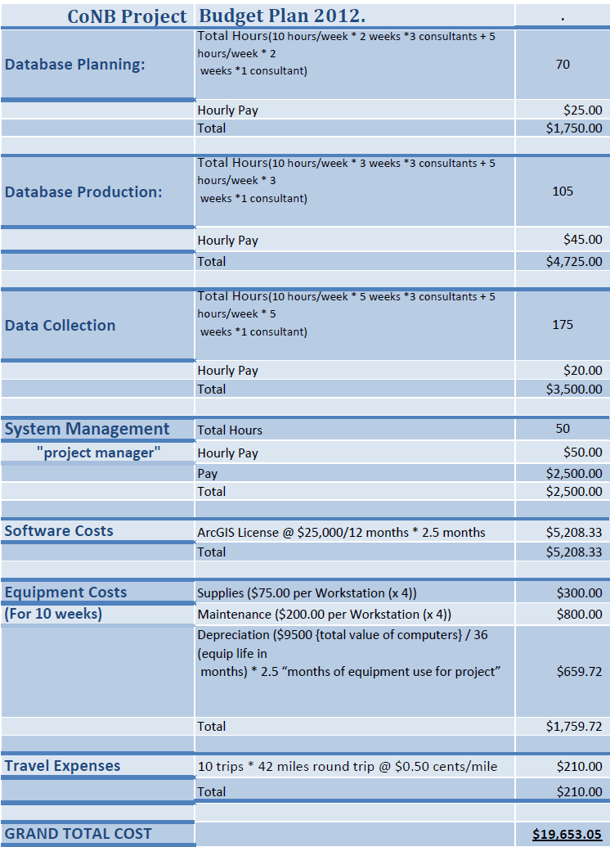

|  |  |  |  |  |  |  |
| --- | --- | --- | --- | --- | --- | --- |
| September 2012  *Needs Assessment/Database Planning* | | | | | | |
| Mon | Tue | Wed | Thur | Fri | Sat | Sun |
|  |  |  |  |  | *1* | *2* |
| **3** | **4** | **5**  **RFP Presentation** | **6** | **7** | *8* | *9* |
| **10** | **11** | **12** | **13** | **14** | *15* | *16* |
| **17** | **18** | **19** | **20** | **21** | *22* | *23* |
| **24** | **25** | **26** | **27** | **28** | *29* | *30* |

4. Timeline

**Asset Management Timetable**

**Phase I: Needs Assessment**

* William Flynn Meeting
* Meeting with Kelly Eby Urban Forester with parks department
* Contact parks personnel
* Contact County personnel

|  |  |  |  |  |  |  |
| --- | --- | --- | --- | --- | --- | --- |
| October 2012  *Needs Assessment/Database Construction* | | | | | | |
| Mon | Tue | Wed | Thur | Fri | Sat | Sun |
| **1**  **Proposal Rehearsal** | **2** | **3**  **Proposal Presentation** | **4** | **5** | *6* | *7* |
| **8** | **9** | **10** | **11** | **12** | *13* | *14* |
| **15** | **16** | **17** | **18** | **19** | *20* | *21* |
| **22** | **23** | **24** | **25** | **26** | *27* | *28* |
| **29** | **30** | **31**  **Progress Report** |  |  |  |  |

**Phase II: Evaluating Existing Data**

* Categorize data between GIS and Accela
* Cross reference feature labels between Accela and ArcGIS
* Manipulate Compatible Data
* Pre-process compatible data

|  |  |  |  |  |  |  |
| --- | --- | --- | --- | --- | --- | --- |
| November 2012  *Database Construction/Data Collection* | | | | | | |
| Mon | Tue | Wed | Thur | Fri | Sat | Sun |
|  |  |  | *1* | *2* | *3* | *4* |
| **5** | **6** | **7** | **8** | **9** | *10* | *11* |
| **12** | **13** | **14** | **15** | **16** | *17* | *18* |
| **19** | **20** | **21** | **22** | **23** | *24* | *25* |
| **26** | **27** | **28** | **29** | **30** |  |  |

**Phase III: Database Modeling/Construction**

* Identify correct data structure between software
* Model data structure
* Create geodatabase compatible with Accela

|  |  |  |  |  |  |  |
| --- | --- | --- | --- | --- | --- | --- |
| December 2012  *Data Collection/Final Presentation* | | | | | | |
| Mon | Tue | Wed | Thur | Fri | Sat | Sun |
|  |  |  |  |  | *1* | *2* |
| **3** | **4** | **5**  **Presentation Rehearsal** | **6** | **7** | *8* | *9* |
| **10**  **Final Presentation** | 11 | 12 | 13 | 14 | *15* | *16* |

**Phase IV: Data Collection/Performance**

* Create relevant data dictionary
* GPS predetermined asset locations
* Process parks data
* Troubleshoot errors
* Implement compatible geodatabase

5. Final Deliverables

These are what our team will deliver at the end of the Project:

* Detailed Final Report (2 Copies)
* Professional Poster for display in the Geography Department
* CD (2 Copies) containing:
  + All Data
  + Metadata
  + Report
  + Poster
  + PowerPoint Presentation
  + Instructions on how to use the CD
    - Readme file
    - Link to our website
* Note that testing will be conducted to ensure no corruption will occur and that all data is usable.

6. Conclusion

The City of New Braunfels lies in arguably one of the most beautiful locations the State of Texas has to offer. The park system is the foundation of the citizen’s ability to relish in the stunning scenery of the city. With government spending always being a primary concern of citizens, it is not easy to maintain and enhance the park areas. With an effective asset management program, the Parks Department is able to provide excellent park services while doing so in the most efficient and cost effective way possible.

The results of this project will be the construction of a geodatabase which will contain spatial and aspatial data on the New Braunfels Parks and Recreation assets. This geodatabase will be implemented in coordination with the New Braunfels Accela software program to efficiently locate, maintain, and better utilize the resources of the Parks Department. Through the synchronization of the constructed geodatabase and Accela, the Parks and Recreation department will be able to remotely assign work orders throughout the city as well as create automatic work orders on time sensitive assets. With the Accela and geodatabase partnership the department will also know the history of the asset, the previous work performed on the asset, typical problems associated with the asset, location and value of each individual asset, and time generally spent to maintain the asset. Physical features of each asset can also be utilized to keep record of the resources the Parks department has and needs to perform maintenance on each individual asset.

The projects consequences will eventually save the City of New Braunfels substantial amounts of money through time that can be used in other needed areas of the government. The gorgeous scenery of the city parks will be maintained more efficiently and cost effectively which will therefore give future generations more beautiful parks, and a better world to live in.

7. Participation

|  |  |
| --- | --- |
| Team Member | Contribution |
| Kevin Scardino: Project Manager | * Cover page, Title page, Data, Contacts, References, Editing |
| Nathan Andrews: Asst. Manager/Web Master | * Cover page, Summary, Purpose, Scope, Budget, Logo, Website Developer, Editing, Organizing |
| Barkley Jenkins: GIS Technician | * Methodology, Implications, Time Line, Conclusion, Editing, Organizing |
| Mukarram Karman: GIS Analyst | * Final Deliverables, References, Power Point, Organizing, Editing |

8. References

* City of New Braunfels, Request For Proposal, City of New Braunfels, Texas, August 2012.
* Dan Saltzman. Portlandonline.com. Total Asset Management, July 2006. Web. September 20, 2012. http://www.portlandonline.com/parks/index.cfm?a=151131&c=38306
* Image 1 : <http://www.newbraunfelsfunthingsinlife.com/>
* Joel Hillhouse. ESRI.com. ArcNews, Spring 2012. Web. September 29, 2012. http://www.esri.com/news/arcnews/spring12articles/city-of-las-vegas-implements-parkpad-for-mobile-asset-management.html
* Lemer, A.C. "Progress Toward Intergrated Infrastructure Asset Management Systems: GIS and Beyond." APWA International Public Works Congress (1998): 1-18.